# Global estimation of dietary micronutrient inadequacies

Simone Passarelli1*^, Christopher M. Free2,3^, Alon Shepon4, Ty Beal5,6, Carolina Batis7, Christopher D. Golden1,8,9

1 Department of Nutrition, Harvard T.H. Chan School of Public Health, Boston, MA 02115, USA

2 Marine Science Institute, University of California, Santa Barbara, Santa Barbara, CA 93117, USA

3 Bren School of Environmental Science and Management, University of California, Santa Barbara, Santa Barbara, CA 93117, USA

4 Department of Environmental Studies, The Porter School of the Environment and Earth Sciences, Tel Aviv University, Israel

5 Institute for Social, Behavioral and Economic Research, University of California, Santa Barbara, CA ​​​​93106, USA

6 Global Alliance for Improved Nutrition, Washington, DC 20036, USA

7 Nutrition and Health Research Center, National Institute of Public Health, Cuernavaca, Morelos, Mexico

8 Department of Environmental Health, Harvard T.H. Chan School of Public Health, Boston, MA 02115, USA

9 Department of Global Health and Population, Harvard T.H. Chan School of Public Health, Boston, MA 02115, USA

**\* Corresponding author:** Office of Global Food Security, U.S. Department of State, Washington, DC 20006; [simoneapassarelli@gmail.com](mailto:simoneapassarelli@gmail.com)

^Both lead authors contributed equally to this publication.

**Keywords:** nutrition, micronutrients, usual intakes, intake inadequacy, diets, malnutrition

## Abstract

### Background

Inadequate micronutrient intakes and related deficiencies are one of the most prevalent public health challenges globally. Yet, our current understanding of their extent has been based on variable and imprecise methods, leading to divergent estimates. Many previous estimates of micronutrient inadequacy have been based on national food supply data rather than dietary data, and their underlying assumptions about populations are not always based on empirical data.

### Methods

We adopted a novel approach to estimating micronutrient intake that accounts for the shape of a population’s nutrient intake distribution, based on dietary intake data from 31 countries. We then applied these distributions to publicly available data from the Global Dietary Database on median nutrient intakes of age-sex subpopulations. Using a globally harmonized set of average nutrient requirements, we calculated the prevalence of global nutrient intake inadequacy for 15 micronutrients in 34 age and sex groups across 218 countries.

### Findings

Based on estimates of nutrient intake from food (excluding fortification and supplementation), over five billion people do not consume enough calcium (72% of global population), iodine (68%), and vitamin E (67%). Over four billion people do not consume enough iron (65%), riboflavin (54%), folate (54%), and vitamin C (53%). Estimated inadequate intakes were higher for women than men for iodine, iron, vitamin B12, and selenium and higher for men than women for calcium, vitamin C, vitamin B6, vitamin A, zinc, magnesium, thiamin, and niacin, within the same country and age groups.

### Interpretation

Our analyses suggest that inadequate intake of key micronutrients could be much higher than previously thought, and that there are notable differences in inadequacy by sex for specific nutrients. This analysis provides the most detailed and population-specific estimates to date of global micronutrient intake inadequacy. These results can be used by public health researchers and practitioners to identify populations in need of dietary intervention to reduce the prevalence of micronutrient deficiencies.

### Funding

Simone Passarelli was supported by National Institutes of Health (NIH) Training Grant

2T32DK007703-26 in Academic Nutrition. No funder played any role in this research. Authors were not precluded from accessing data in the study, and they accept responsibility to submit for publication.

## 1. Introduction

Nutrition is the most modifiable environmental factor we have to improve health worldwide. Estimates show that improvements to our diets could prevent about one in every five deaths.[1](https://www.zotero.org/google-docs/?Zkgx2l)

One of the most common forms of malnutrition globally is micronutrient deficiency.[2](https://www.zotero.org/google-docs/?MDJMnO) Inadequate intake of nutrients like iron, zinc, vitamin A, iodine, and folate are widespread, and each nutrient carries its own public health consequences. Iron deficiency is the most common cause of anemia and is estimated to affect over a billion people worldwide, leading to impaired cognition and adverse pregnancy outcomes.[3](https://www.zotero.org/google-docs/?fH3Tiq) Vitamin A deficiency is the leading cause of preventable blindness globally. Both vitamin A and zinc play a critical role in immunity, especially for populations facing a high burden of infectious diseases.[4,5](https://www.zotero.org/google-docs/?thLVTB) Folate is needed early in pregnancy to prevent stillbirths and neural tube defects, and iodine is essential for pregnant and breastfeeding women due to its role in fetal and child cognitive development.[6](https://www.zotero.org/google-docs/?QR1C5z)

Deficiencies in these micronutrients and others collectively contribute to excess morbidity, mortality, and chronic undernutrition, but the scale of the problem is relatively unknown due to limited data. To tackle such a large-scale public health crisis, we need estimates to diagnose which nutrients pose the greatest risk, where, and to whom.[7](https://www.zotero.org/google-docs/?ntoSFW) While we know micronutrient deficiency is widespread, we have only rough estimates for how many people it affects. For example, a pooled analysis of biomarker data found that worldwide 1 in 2 children under age five are affected by either iron, zinc, and/or vitamin A deficiency and 2 in 3 women aged 15–49 years are affected by either iron, zinc, and/or folate micronutrient deficiency. However, there are no recent estimates of individual nutrient deficiencies worldwide for a wider range for nutrients and for other age groups.[2](https://www.zotero.org/google-docs/?C9S4Uc)

There have been numerous efforts to estimate the burden of global micronutrient malnutrition, and significant methodological advances.[8,9](https://www.zotero.org/google-docs/?ahWWZl) Yet, different approaches have resulted in substantially different estimates, limiting the ability to draw robust conclusions and design effective interventions.[10,11](https://www.zotero.org/google-docs/?Ya3lja) Such disparate results suggest both insufficient underlying data and limited methodologies, leading to poor replicability.[11](https://www.zotero.org/google-docs/?kaFhV7) New methodological approaches are needed to achieve more replicable and reliable results.[10](https://www.zotero.org/google-docs/?XJSR5o)

Estimates of nutrient intake inadequacy tend to rely on food supply data, biomarkers, dietary data, or some combination of these sources–each with its own gaps and limitations.[12](https://www.zotero.org/google-docs/?N0IZWW) Many studies use nutrient supply data, like FAO food balance sheets or food expenditure data.[8,13–16](https://www.zotero.org/google-docs/?sbwnRn) While these methods are useful for global estimation, they have notable shortcomings. First, they rely solely on an indirect measure–food supply–as a proxy for individual-level food consumption. As a result, some analyses might not fully account for food waste, intrahousehold allocation, heterogeneity due to age and sex, food consumed outside the home, or differential absorption.[5](https://www.zotero.org/google-docs/?W0r6Vy) Due to these limitations, supply-based estimates are often drastic overestimates of intake, which can lead to underestimation of intake inadequacy.[11](https://www.zotero.org/google-docs/?5igJhS)

In contrast to approaches based on food supply data, the Global Burden of Disease (GBD) Study examined the prevalence of malnutrition through a modeling approach. They compiled data from 195 countries to examine the role of nutrition as both a risk factor and outcome for four micronutrients: iodine, iron, zinc, and vitamin A.[17](https://www.zotero.org/google-docs/?y1giyR) To estimate the global prevalence of disease, they used a combination of biomarkers and clinical conditions like goiter for iodine, hemoglobin for iron, retinol for vitamin A, and food intake inadequacy for zinc. Their approach, however, requires complex modeling techniques and clinical proxies that are likely to underestimate the prevalence of deficiency, and consequently, disease burden.[17](https://www.zotero.org/google-docs/?70k4uv) Furthermore, their data, methods, code, and assumed nutrient distribution shapes are not publicly available, making their technical approach impossible to replicate.[18](https://www.zotero.org/google-docs/?OSRPxi)

Another effort that estimates global dietary intake is the Global Dietary Database (GDD).[19](https://www.zotero.org/google-docs/?4TMcBb) For 10 years, the GDD has standardized and compiled individual-level dietary datasets from 185 countries for over 50 foods, beverages, and nutrients.[19,20](https://www.zotero.org/google-docs/?kSugFs) Based on these data, researchers have estimated median intake levels of these dietary factors for age-sex sub-groups around the world through a Bayesian modeling approach.

Yet, existing estimates of nutrient intake or inadequacy do not fully account for a population’s intake distribution, which can lead to biased results. In general, population inadequacy is estimated based on a mean or median nutrient consumption level rather than a full distribution. Previous research has shown that assuming a normal distribution or a uniformly skewed distribution around a mean or median leads to measurement error and biased results.[21](https://www.zotero.org/google-docs/?y0Qd52) The resulting analyses could greatly overestimate or underestimate inadequacy if the assumed shape is incorrect. Most analyses have relied on a simplified approach (known as the cut-point method) to assess inadequate intake, which does not require knowledge of the shape as long as specific criteria are met[22](https://www.zotero.org/google-docs/?g9rBMT), but may provide less accurate results.[23](https://www.zotero.org/google-docs/?Do5yb9) Although GBD does assume distribution shapes, their distributions are not modeled on a global scale and their methods are not publicly available.

This manuscript provides a novel and reproducible approach to estimating global nutrient inadequacy by accounting for greater nuance in the shapes of nutrient intake distributions. We seek to measure the adequacy of dietary micronutrient intake to estimate the percentage of global sub-populations at risk of deficiency. Using intake distribution shapes developed by Passarelli et al.[21](https://www.zotero.org/google-docs/?SsGNdQ) in combination with dietary intake estimates from GDD[19](https://www.zotero.org/google-docs/?B59Tyw), we estimate the global prevalence of intake inadequacy for 15 micronutrients in 34 subnational age and sex groups across 218 countries. We evaluate inadequacy using a globally harmonized set of dietary intake requirements developed by Allen et al.[24](https://www.zotero.org/google-docs/?a9P9TJ)

## 2. Methods

### 2.1 Overview

We estimated nutrient intake inadequacies for 15 micronutrients (**Table S1)** across 34 subnational age-sex groups in 218 countries. This approach required understanding nutrient intake and requirement distributions for every subnational population globally. We developed subnational nutrient intake distributions using estimates of (1) distribution scale (i.e., intake median) from the Global Dietary Database (GDD) and (2) distribution shape (i.e., intake variability) from the nutriR database.[21](https://www.zotero.org/google-docs/?Kuv8i5) We developed subnational nutrient requirement distributions using the harmonized average requirements defined by Allen et al.[24](https://www.zotero.org/google-docs/?EUtUCH) and common assumptions about the levels of requirement variability. We used the probability method[23](https://www.zotero.org/google-docs/?nIH4u4) to calculate intake inadequacies by comparing the derived intakes against the requirement distributions and calculated the number of people with intake adequacies using subnational human population size estimates from the World Bank.[25](https://www.zotero.org/google-docs/?bQ0PfV) All analyses were done using R[26](https://www.zotero.org/google-docs/?ubrWwA) and all data and code are available on GitHub here: <https://github.com/cfree14/global_intake_inadequacies>. An interactive R Shiny web application for exploring the results in detail is available here: <https://emlab-ucsb.shinyapps.io/global_intake_inadequacies/>

### 2.2 Defining subnational populations

We defined countries and subpopulations based on estimates of human population size provided by the World Bank.[25](https://www.zotero.org/google-docs/?1gn0kU) The World Bank estimates human population size within 34 age-sex groups (males and females in 17 age groups: 0- to 80-yrs-old in 5-yr groups, plus an 80+ age group) for 218 countries or territories. We refer to these country-age-sex groups as subnational populations throughout this paper. We used estimates for 2018 given that this is the most recent year with GDD data (described below). In 2018, the global population was approximately 7.57 billion people (**Figure S1A**).

### 2.3 Defining subnational intake means

We developed subnational nutrient intake distributions with median intakes equivalent to the nutrient intake estimates provided in the Global Dietary Database (GDD).[19,27](https://www.zotero.org/google-docs/?XJjQYr) The GDD uses datasets from food balance sheets and household surveys to estimate the median intake of 17 micronutrients from 19 food and beverage categories (**Table S2**) to highly resolved subpopulations in 185 countries from 1990-2018 (5-yr intervals 1990-2015). Subpopulations are defined by 44 age-sex groups, three levels of education (i.e., low, medium, and high), and two areas of residence (i.e., rural and urban). We assumed that the nutrient intakes of 33 small or data-deficient countries without GDD intake estimates were equivalent to those of their most similar geographic neighbor (**Figure S2; Table S3**). We excluded two nutrients from the analysis: (1) potassium, which does not have accepted average requirement levels, and (2) vitamin D, which is highly geographically variable because the average requirement levels can be met through sun exposure rather than dietary intake.[24](https://www.zotero.org/google-docs/?yZvupo) This leaves 15 micronutrients (9 vitamins and 6 minerals) available for analysis (**Table S1)**. We defined median intakes by age-sex group averaged across areas of residence and levels of education. We then averaged these intake estimates to match the age groups used in the Word Bank human population data following **Table S4**. Finally, to account for the supply of calcium in water, we added an additional 71.4 mg of calcium to every intake estimate. This is based on an assumption of 1.7 L of daily water intake with an average calcium concentration of 42 mg/L.[8](https://www.zotero.org/google-docs/?jnOkPk)

### 2.4 Defining subnational intake shapes

We defined the shape of each subnational nutrient intake distribution using estimates of subnational nutrient intake shapes provided in the nutriR database.[21,28](https://www.zotero.org/google-docs/?HLKY9B) Passarelli et al.[21](https://www.zotero.org/google-docs/?dPR9v5) assembled a database of dietary recall surveys from 31 countries and used this database to construct statistical distributions -- either log-normal or gamma distributions -- that describe usual intakes for 51 nutrients. Due to limitations in the coverage of dietary recall surveys, distribution shapes are not available for all subnational groups, even within the 31 countries with data. Thus, we matched every subnational group evaluated in this paper with the shape parameters of the most similar subnational group with data. We performed this matching with preference for shape parameters from: (1) the actual subpopulation (“known”); (2) the nearest age-group within the country and sex (“nearest age group”); (3) the corresponding age-group from the opposite sex within a country (“opposite sex”); and (4) the corresponding age-sex group from the country with the most similar nutrient intakes to the country of interest (“most similar country”). We identified the country with the most similar nutrient intakes to the country of interest as the country with the smallest Euclidean distance in a dissimilarity matrix computed using the 2018 national nutrient intakes estimated in the GDD (**Figure S3**); in other words, the country with the most similar nutrient intakes in multivariate space. **Figure S4** illustrates the extent and sources of borrowed shape information.

### 2.5 Defining subnational intake distributions

We specified the final usual intake distribution for each subnational group using its median value and matched shape parameters. The matched shape parameters describe the variability of each distribution but produce different medians than those prescribed by the GDD estimates. Therefore, we shifted the shape parameters to match the GDD median while maintaining the variability described by the matched shape parameters. For intake distributions parameterized using a log-normal distribution, we maintained the variability parameter, *σ*, and shifted the centrality parameter, *µ*. For intake distributions parameterized using a gamma distribution, we maintained the variability parameter, *α*, and shifted the centrality parameter, *β*. The shifted parameters were derived analytically for the log-normal distribution and numerically for the gamma distribution using the *shift_dist()* function in the *nutriR* package.[28](https://www.zotero.org/google-docs/?4nWweg) See **Figure S5** for a conceptual illustration of these distribution shifts.

### 2.6 Estimating subnational intake inadequacy

We estimated the prevalence of intake inadequacy, also known as summary exposure value (SEV), using the probability method[23](https://www.zotero.org/google-docs/?tPSsRz) as implemented in the *nutriR* package.[28](https://www.zotero.org/google-docs/?fz4OWK) The probability method compares intake distributions against a continuous relative risk curve with a value of 1 at low intakes, 0.5 at the average intake requirement, and 0 at large intakes. These risk curves are defined based on the cumulative normal distribution described by the average requirement and its standard deviation. We used the harmonized average requirements (ARs) provided by Allen et al.[24](https://www.zotero.org/google-docs/?SYno6W) as the average requirements for this analysis (**Figure S6**). We assumed a coefficient of variation of 0.25 for the requirement of vitamin B12 and 0.10 for the requirement of all other distributions based on the recommendation of Renwick et al.[29](https://www.zotero.org/google-docs/?e81XQN).

We specified country-specific ARs for zinc and iron based on dietary factors that inhibit or enhance their absorption (**Figure S7 & S8**). First, phytate inhibits zinc and iron absorption,[30](https://www.zotero.org/google-docs/?Gxr9HN) which means that ARs for zinc and iron increase with higher phytate intakes.[24](https://www.zotero.org/google-docs/?abLvZr) Second, non-dairy animal-source food consumption enhances iron absorption,[31](https://www.zotero.org/google-docs/?ve90oD) which means that ARs for iron decrease with higher non-dairy animal-source food (ASF) intakes.[24](https://www.zotero.org/google-docs/?dVHQD6) We derived country-specific ARs for zinc based on average country-level estimates of phytate intake from Wessels and Brown[32](https://www.zotero.org/google-docs/?lhlTWv) (**Figure S9**) by linearly interpolating between the lowest AR and lowest phytate intake and the highest AR and highest phytate intake within each age-sex group (**Figure S7**).

We derived country-specific ARs for iron accounting for the joint impacts of phytate and non-dairy ASF on iron absorption using a procedure similar to Beal et al.[8](https://www.zotero.org/google-docs/?mFAXzG) First, we scaled the country-level phytate intakes (**Figure S9**) between 0 and 1, where 0 indicates low iron absorption (high phytate intake) and 1 indicates high absorption (low phytate intake). Then, we scaled country-level estimates of non-dairy ASF intakes (i.e., sum of seafood, processed meat, unprocessed red meat, and egg intakes–note that the GDD excludes unprocessed poultry meat, which is why we have excluded it from the iron bioavailability algorithm; **Table S2; Figure S10**) from the GDD[19](https://www.zotero.org/google-docs/?2SRUCw) between 0 and 1, where 0 indicates low iron absorption (low non-dairy ASF intake) and 1 indicates high absorption (high non-dairy ASF intake). Next, we averaged these two indicators to create a single absorption index, where lower values indicate lower absorption and higher values indicate higher absorption, and scaled these averages between 5% and 16% absorption, the range of real-world iron absorption levels[24](https://www.zotero.org/google-docs/?5SgaUf) (**Figure S11**). Finally, we derived the absorption-specific ARs by linearly interpolating between the ARs specified by Allen et al.[24](https://www.zotero.org/google-docs/?jqzJ8N) (**Figure S8**).

We calculated the number of people within each subnational group with inadequate intakes as the product of the number of people and prevalence of inadequate intakes in the group.

## 3. Results

We found a high prevalence of estimated intake inadequacy for most of the evaluated nutrients (**Figure 1**). Inadequate intake estimates were especially common for calcium (72% of people), iodine (68% of people), vitamin E (67% of people), and iron (65% of people). Niacin exhibited the lowest level of inadequate intake (22% of people) followed by thiamin (30% of people) and selenium (37% of people) (**Figure 1**). A few countries exhibited estimated intake inadequacies that diverged from the general patterns. For example, India exhibited especially high estimated inadequate intakes of riboflavin, folate, vitamin B6, and vitamin B12; Madagascar and the Democratic Republic of the Congo exhibited higher inadequate niacin intake; and Russia, Mongolia, and Kazakhstan exhibited higher inadequate selenium intake (**Figure 1**).

Calcium intake inadequacy was highest in countries in South Asia, Sub-Saharan Africa, and East Asia and the Pacific (**Figure 2**). Intake inadequacy was high across all age-sex groups in these countries, but especially among 10–30 year-olds. Only countries in North America, Europe, and Central Asia exhibited consistently low levels of inadequate calcium intakes. The remaining countries exhibited moderate levels of inadequate calcium intakes, with heightened vulnerability for 10–30 year-olds, and especially for females (**Figure 2**).

Low levels of inadequate iodine intakes were only observed in Europe, New Zealand, and Australia (**Figures 1 & 2**), and for vitamin E, in Pacific Island countries (**Figures 1 & 2**). For riboflavin, high levels of inadequate intakes were only common in India and other countries in South Asia (**Figures 1 & 2**). The prevalence of inadequate selenium intakes was only high in Russia and other eastern European and central Asian countries (**Figures 1 & 2**), while inadequate vitamin B12 intakes were only high in South Asia (**Figure 2**).

Globally, the prevalence of inadequate intakes was consistently higher for females than for males in the same country and age group for iodine, vitamin B12, iron, and selenium (**Figure 3**). The prevalence of inadequate intakes was higher for females than males in most regions (not in south-eastern Asia and North America) for riboflavin, vitamin E, and folate. Conversely, the prevalence of inadequate intakes was consistently higher for males than females in the same country and age group for calcium, niacin, thiamin, vitamin A, zinc, vitamin C, vitamin B6, and magnesium (**Figure 3**).

## 4. Discussion

This analysis provides a new, replicable, and accessible methodology for estimating micronutrient intake inadequacy. Globally, we found that five billion people do not consume enough of three nutrients–calcium, iodine, and vitamin E. Over four billion people do not consume enough iron, riboflavin, folate, and vitamin C. Our analysis demonstrates that the majority of the global population has inadequate micronutrient intake, and this likely corresponds with micronutrient deficiency in the majority of the global population.

Our analysis is subject to limitations–most notably, data availability. There remains a lack of individual dietary intake data worldwide, especially nationally representative datasets and datasets with two or more days of intake. This limits the number of statistical distributions that can be estimated in the nutriR database. GDD data are subject to similar limitations as methods that estimate food supply, including limited accuracy and complexity of underlying food composition data. Although GDD coverage has grown to include 98% of the global population and become more precise over time,[14](https://www.zotero.org/google-docs/?brb869) many of its underlying datasets have limited data. The estimates presented in this paper are of inadequate nutrient intake and not based on biomarker data, and they exclude supplementation and fortification. Nonetheless, there is little supplementation and fortification with most of these micronutrients globally. Among countries with available Demographic and Health Survey (DHS) data, supplementation is somewhat common for iron, with 32% of pregnant women consuming iron for >90 days of their pregnancy, and 14% of children consuming a supplement in the previous week.[33](https://www.zotero.org/google-docs/?QUmk1h) Supplementation is the highest for vitamin A in children; an estimated 55% have had a dose in the previous six months.[33](https://www.zotero.org/google-docs/?Tm1U1r) There is inadequate data on fortification for most nutrients except iodine; UNICEF estimates that 89% of people worldwide consume iodized salt.[34](https://www.zotero.org/google-docs/?4ZfQjd) Thus, iodine might be the only nutrient for which inadequate intake from food is a poor indicator of deficiency in most populations.

We found that globally, women faced a higher prevalence of estimated intake inadequacy relative to men for a number of nutrients, including iodine, iron, vitamin B12, vitamin E, folate, riboflavin, and selenium. Conversely, there are several nutrients for which men have higher intake inadequacies compared to women, including for calcium, vitamin C, vitamin B6, vitamin A, zinc, magnesium, thiamin, and niacin. Although a recent analysis found moderate levels of global B12 deficiency, their analysis used a higher threshold for requirements and FAO food balance sheets rather than dietary data.[15](https://www.zotero.org/google-docs/?WNQJjd) GDD data analyses have found that women globally have better dietary quality scores compared to men,[35](https://www.zotero.org/google-docs/?NTx1ib) and that animal source food consumption does not differ substantially between men and women, other than slight variations in the types of foods consumed.[36](https://www.zotero.org/google-docs/?afsNdK) Thus, many of the differences observed may relate to a combination of differing dietary patterns between sexes, dietary requirements, and consumption quantities.

Although no studies have assessed inadequate intakes for this many nutrients globally, our findings are supported by existing research. Stevens et al.[2](https://www.zotero.org/google-docs/?iH0Cjl) assessed micronutrient deficiency based on biomarker data for all datasets available globally (24 nationally-representative datasets) for non-pregnant women and preschool aged children, estimating that over half of preschool-aged children and two-thirds of non-pregnant women have micronutrient deficiencies. Our estimates generally show a higher prevalence of intake inadequacy compared to their biomarker data. One reason for this difference might be that our estimates do not include supplements and fortified foods, so our estimates are reflective of nutrient adequacy from unfortified foods. Additionally, nutritional deficiencies, as measured by clinical biomarkers, although highly correlated with nutrient intake,[37](https://www.zotero.org/google-docs/?maDYP0) may be strongly influenced by disease status, inflammation, microbiome, and other contextual factors.

This paper builds on work that estimates the global prevalence of micronutrient deficiencies, inadequate intakes, or inadequate supply. Notably, the GDD uses actual dietary intake data rather than food supply or household food purchase data. Ours is the first analysis to apply nutrient intake distributions to actual intake data using age- and sex-specific intake distributions on a global scale. We also incorporated within-person variation in our underlying nutrient distributions by only including datasets with two or more days of dietary intake. This is especially important for low-income populations, where some types of foods are consumed infrequently.

## 5. Conclusions

This paper highlights the vast scale of micronutrient intake inadequacy across the world–especially for calcium, iodine, vitamin E, iron, riboflavin, and folate. Clear patterns emerged for differing levels of estimated inadequacy for specific nutrients on the basis of sex, more so than across age groups within a given sex. Understanding these patterns can help us to better understand where nutritional interventions are needed, such as dietary interventions, biofortification, fortification, and supplementation. Moreover, examining which nutrient intake inadequacies are correlated with each other can help to identify which nutritional responses need to be coordinated to improve the efficiency of intervention delivery. However, the results presented here only point to where further assessment of actual micronutrient status is needed. Severely nutritionally lacking geographies warrant further investigation into the causes and severity of deficiencies before adopting fortification, supplementation, and dietary intervention policies.

This analysis represents the first-ever estimate of inadequate micronutrient intakes globally, across diverse subpopulations. While previous global analyses have focused on a selection of commonly studied nutrients–including vitamin A, iron, zinc, and iodine–our analysis adds additional and important nutrients, like vitamin B12, selenium, and calcium. We have made our code and underlying data freely available so that others can use and build upon these results. We hope that the added precision and scope of this analysis improves our understanding of global micronutrient inadequacy so that public health interventions can be better equipped to address deficiencies.

## Acknowledgements

Simone Passarelli was supported by the National Institutes of Health (NIH) Training Grant

2T32DK007703-26 in Academic Nutrition. Ty Beal was supported by contributions from the Dutch Ministry of Foreign Affairs.

## 

## References

[1 Afshin A, Sur PJ, Fay KA, *et al.* Health effects of dietary risks in 195 countries, 1990–2017: a systematic analysis for the Global Burden of Disease Study 2017. *The Lancet* 2019; **393**: 1958–72.](https://www.zotero.org/google-docs/?eB7B2S)

[2 Stevens GA, Beal T, Mbuya MNN, *et al.* Micronutrient deficiencies among preschool-aged children and women of reproductive age worldwide: a pooled analysis of individual-level data from population-representative surveys. *Lancet Glob Health* 2022; **10**: e1590–9.](https://www.zotero.org/google-docs/?eB7B2S)

[3 Camaschella C. Iron deficiency. *Blood* 2019; **133**: 30–9.](https://www.zotero.org/google-docs/?eB7B2S)

[4 Imdad A, Herzer K, Mayo‐Wilson E, Yakoob MY, Bhutta ZA. Vitamin A supplementation for preventing morbidity and mortality in children from 6 months to 5 years of age. *Cochrane Database Syst Rev* 2010. DOI:10.1002/14651858.CD008524.pub2.](https://www.zotero.org/google-docs/?eB7B2S)

[5 Wessells KR, Singh GM, Brown KH. Estimating the Global Prevalence of Inadequate Zinc Intake from National Food Balance Sheets: Effects of Methodological Assumptions. *PLOS ONE* 2012; **7**: e50565.](https://www.zotero.org/google-docs/?eB7B2S)

[6 Victora CG, Christian P, Vidaletti LP, Gatica-Domínguez G, Menon P, Black RE. Revisiting maternal and child undernutrition in low-income and middle-income countries: variable progress towards an unfinished agenda. *The Lancet* 2021; **397**: 1388–99.](https://www.zotero.org/google-docs/?eB7B2S)

[7 2021 Global Nutrition Report: The state of global nutrition. Bristol, UK: Development Initiatives, 2021 https://globalnutritionreport.org/reports/2021-global-nutrition-report/ (accessed Feb 11, 2022).](https://www.zotero.org/google-docs/?eB7B2S)

[8 Beal T, Massiot E, Arsenault JE, Smith MR, Hijmans RJ. Global trends in dietary micronutrient supplies and estimated prevalence of inadequate intakes. *PLOS ONE* 2017; **12**: e0175554.](https://www.zotero.org/google-docs/?eB7B2S)

[9 GBD 2019 Risk Factors Collaborators. Global burden of 87 risk factors in 204 countries and territories, 1990-2019: a systematic analysis for the Global Burden of Disease Study 2019. *Lancet Lond Engl* 2020; **396**: 1223–49.](https://www.zotero.org/google-docs/?eB7B2S)

[10 Beal T, Herforth A, Sundberg S, Hess SY, Neufeld LM. Differences in modelled estimates of global dietary intake. *The Lancet* 2021; **397**: 1708–9.](https://www.zotero.org/google-docs/?eB7B2S)

[11 Del Gobbo LC, Khatibzadeh S, Imamura F, *et al.* Assessing global dietary habits: a comparison of national estimates from the FAO and the Global Dietary Database. *Am J Clin Nutr* 2015; **101**: 1038–46.](https://www.zotero.org/google-docs/?eB7B2S)

[12 Brown KH, Moore SE, Hess SY, *et al.* Increasing the availability and utilization of reliable data on population micronutrient (MN) status globally: the MN Data Generation Initiative. *Am J Clin Nutr* 2021; **114**: 862–70.](https://www.zotero.org/google-docs/?eB7B2S)

[13 Arsenault JE, Hijmans RJ, Brown KH. Improving nutrition security through agriculture: an analytical framework based on national food balance sheets to estimate nutritional adequacy of food supplies. *Food Secur* 2015; **7**: 693–707.](https://www.zotero.org/google-docs/?eB7B2S)

[14 Smith MR, Micha R, Golden CD, Mozaffarian D, Myers SS. Global Expanded Nutrient Supply (GENuS) Model: A New Method for Estimating the Global Dietary Supply of Nutrients. *PLOS ONE* 2016; **11**: e0146976.](https://www.zotero.org/google-docs/?eB7B2S)

[15 Wang X, Dou Z, Feng S, *et al.* Global food nutrients analysis reveals alarming gaps and daunting challenges. *Nat Food* 2023; **4**: 1007–17.](https://www.zotero.org/google-docs/?eB7B2S)

[16 Lividini K, Masters WA. Tracing global flows of bioactive compounds from farm to fork in nutrient balance sheets can help guide intervention towards healthier food supplies. *Nat Food* 2022; **3**: 703–15.](https://www.zotero.org/google-docs/?eB7B2S)

[17 Hess SY, McLain AC, Frongillo EA, *et al.* Challenges for Estimating the Global Prevalence of Micronutrient Deficiencies and Related Disease Burden: A Case Study of the Global Burden of Disease Study. *Curr Dev Nutr* 2021; **5**: nzab141.](https://www.zotero.org/google-docs/?eB7B2S)

[18 McLain AC, Frongillo EA, Hess SY, Piwoz EG. Comparison of Methods Used to Estimate the Global Burden of Disease Related to Undernutrition and Suboptimal Breastfeeding. *Adv Nutr* 2019; **10**: 380–90.](https://www.zotero.org/google-docs/?eB7B2S)

[19 The GDD Prediction Model | Global Dietary Database. https://www.globaldietarydatabase.org/gdd-prediction-model (accessed Feb 14, 2022).](https://www.zotero.org/google-docs/?eB7B2S)

[20 Miller V, Singh GM, Onopa J, *et al.* Global Dietary Database 2017: data availability and gaps on 54 major foods, beverages and nutrients among 5.6 million children and adults from 1220 surveys worldwide. *BMJ Glob Health* 2021; **6**: e003585.](https://www.zotero.org/google-docs/?eB7B2S)

[21 Passarelli S, Free CM, Allen LH, *et al.* Estimating national and subnational nutrient intake distributions of global diets. *Am J Clin Nutr* 2022; : nqac108.](https://www.zotero.org/google-docs/?eB7B2S)

[22 Institute of Medicine. Prevention of Micronutrient Deficiencies: Tools for Policymakers and Public Health Workers. Washington, D.C.: National Academies Press, 1998 DOI:10.17226/5962.](https://www.zotero.org/google-docs/?eB7B2S)

[23 National Research Council (US) Subcommittee on Criteria for Dietary Evaluation. Nutrient Adequacy: Assessment Using Food Consumption Surveys. Washington (DC): National Academies Press (US), 1986.](https://www.zotero.org/google-docs/?eB7B2S)

[24 Allen LH, Carriquiry AL, Murphy SP. Perspective: Proposed Harmonized Nutrient Reference Values for Populations. *Adv Nutr* 2020; **11**: 469–83.](https://www.zotero.org/google-docs/?eB7B2S)

[25 World Bank. Population, total. World Dev. Indic. 2020.](https://www.zotero.org/google-docs/?eB7B2S)

[26 R Core Team. R: A Language and Environment for Statistical Computing. 2022. https://www.R-project.org/.](https://www.zotero.org/google-docs/?eB7B2S)

[27 Karageorgou D, Lara-Castor L, Leclercq C, *et al.* Harmonizing Dietary Datasets Around the World for Global Diet Monitoring: Methods from the Global Dietary Database and the Global Individual Food Consumption Data Tool (OR06-06-19). *Curr Dev Nutr* 2019; **3**: nzz039.OR06-06-19.](https://www.zotero.org/google-docs/?eB7B2S)

[28 Free CM, Passarelli S, Allen LH, *et al.* nutriR: Nutritional intake functions for R. 2022. https://github.com/cfree14/nutriR.](https://www.zotero.org/google-docs/?eB7B2S)

[29 Renwick AG, Flynn A, Fletcher RJ, Müller DJG, Tuijtelaars S, Verhagen H. Risk-benefit analysis of micronutrients. *Food Chem Toxicol Int J Publ Br Ind Biol Res Assoc* 2004; **42**: 1903–22.](https://www.zotero.org/google-docs/?eB7B2S)

[30 Miller LV, Krebs NF, Hambidge KM. A Mathematical Model of Zinc Absorption in Humans As a Function of Dietary Zinc and Phytate. *J Nutr* 2007; **137**: 135–41.](https://www.zotero.org/google-docs/?eB7B2S)

[31 Hurrell RF, Reddy MB, Juillerat M, Cook JD. Meat Protein Fractions Enhance Nonheme Iron Absorption in Humans. *J Nutr* 2006; **136**: 2808–12.](https://www.zotero.org/google-docs/?eB7B2S)

[32 Wessells KR, Brown KH. Estimating the Global Prevalence of Zinc Deficiency: Results Based on Zinc Availability in National Food Supplies and the Prevalence of Stunting. *PLOS ONE* 2012; **7**: e50568.](https://www.zotero.org/google-docs/?eB7B2S)

[33 STATcompiler. https://www.statcompiler.com/en/ (accessed Aug 31, 2023).](https://www.zotero.org/google-docs/?eB7B2S)

[34 UNICEF. Global Database, based on: Multiple Indicator Cluster Surveys (MICS), Demographic and Health Surveys (DHS) and other nationally representative household surveys, 2015–2021. 2022.](https://www.zotero.org/google-docs/?eB7B2S)

[35 Miller V, Webb P, Cudhea F, *et al.* Global dietary quality in 185 countries from 1990 to 2018 show wide differences by nation, age, education, and urbanicity. *Nat Food* 2022; **3**: 694–702.](https://www.zotero.org/google-docs/?eB7B2S)

[36 Miller V, Reedy J, Cudhea F, *et al.* Global, regional, and national consumption of animal-source foods between 1990 and 2018: findings from the Global Dietary Database. *Lancet Planet Health* 2022; **6**: e243–56.](https://www.zotero.org/google-docs/?eB7B2S)

[37 Fraser GE, Jaceldo-Siegl K, Henning SM, *et al.* Biomarkers of Dietary Intake Are Correlated with Corresponding Measures from Repeated Dietary Recalls and Food-Frequency Questionnaires in the Adventist Health Study-2123. *J Nutr* 2016; **146**: 586–94.](https://www.zotero.org/google-docs/?eB7B2S)

## Tables and Figures

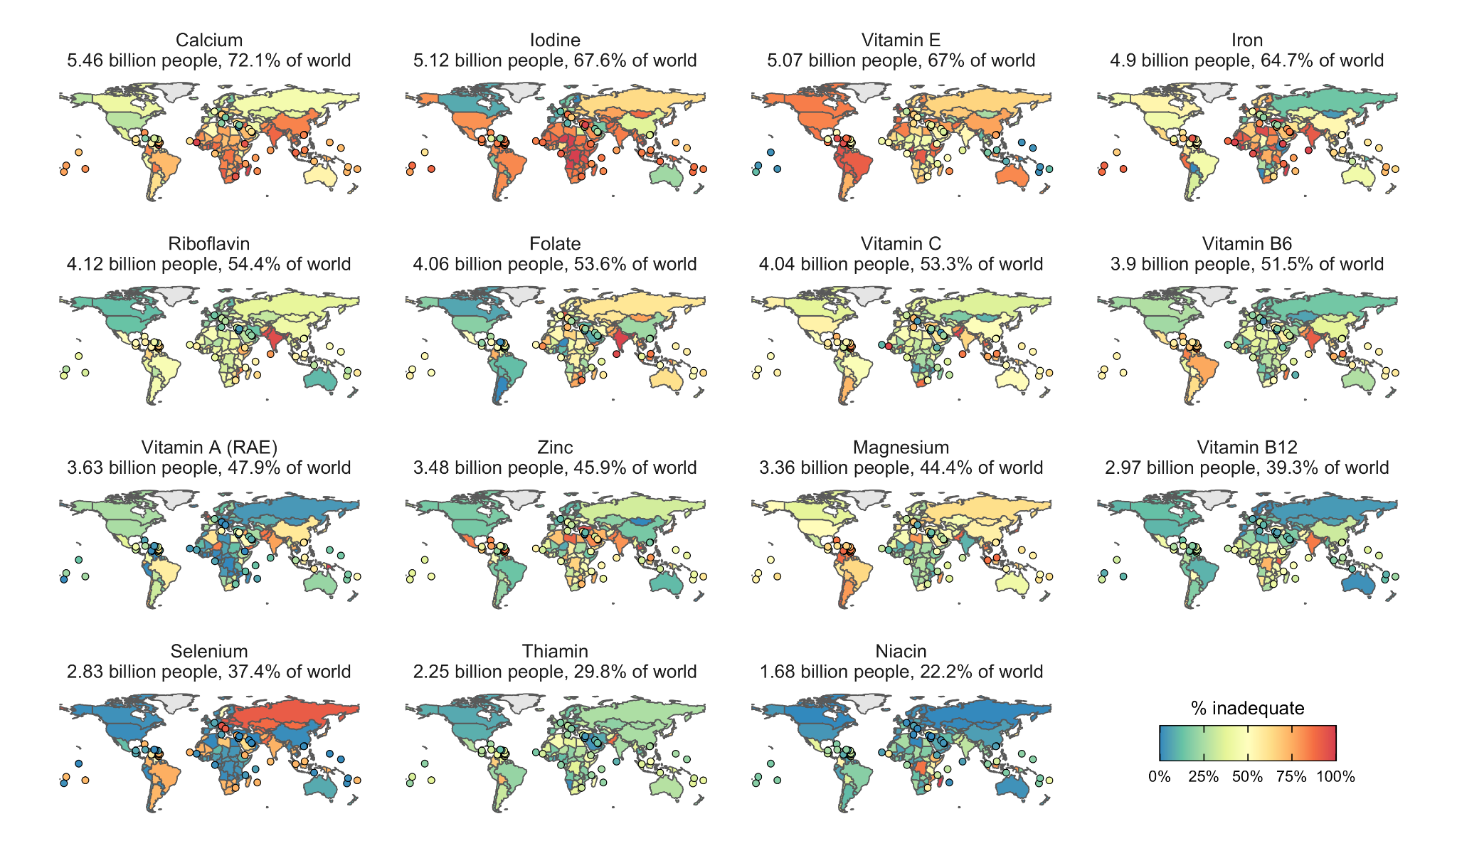**Figure 1.** Estimated prevalence of intake inadequacies by country and nutrient in 2018. The estimated number and proportion of the global population with inadequacies is labeled inside each map. Countries with land areas less than 25,000 km2 are shown as points to increase visibility.

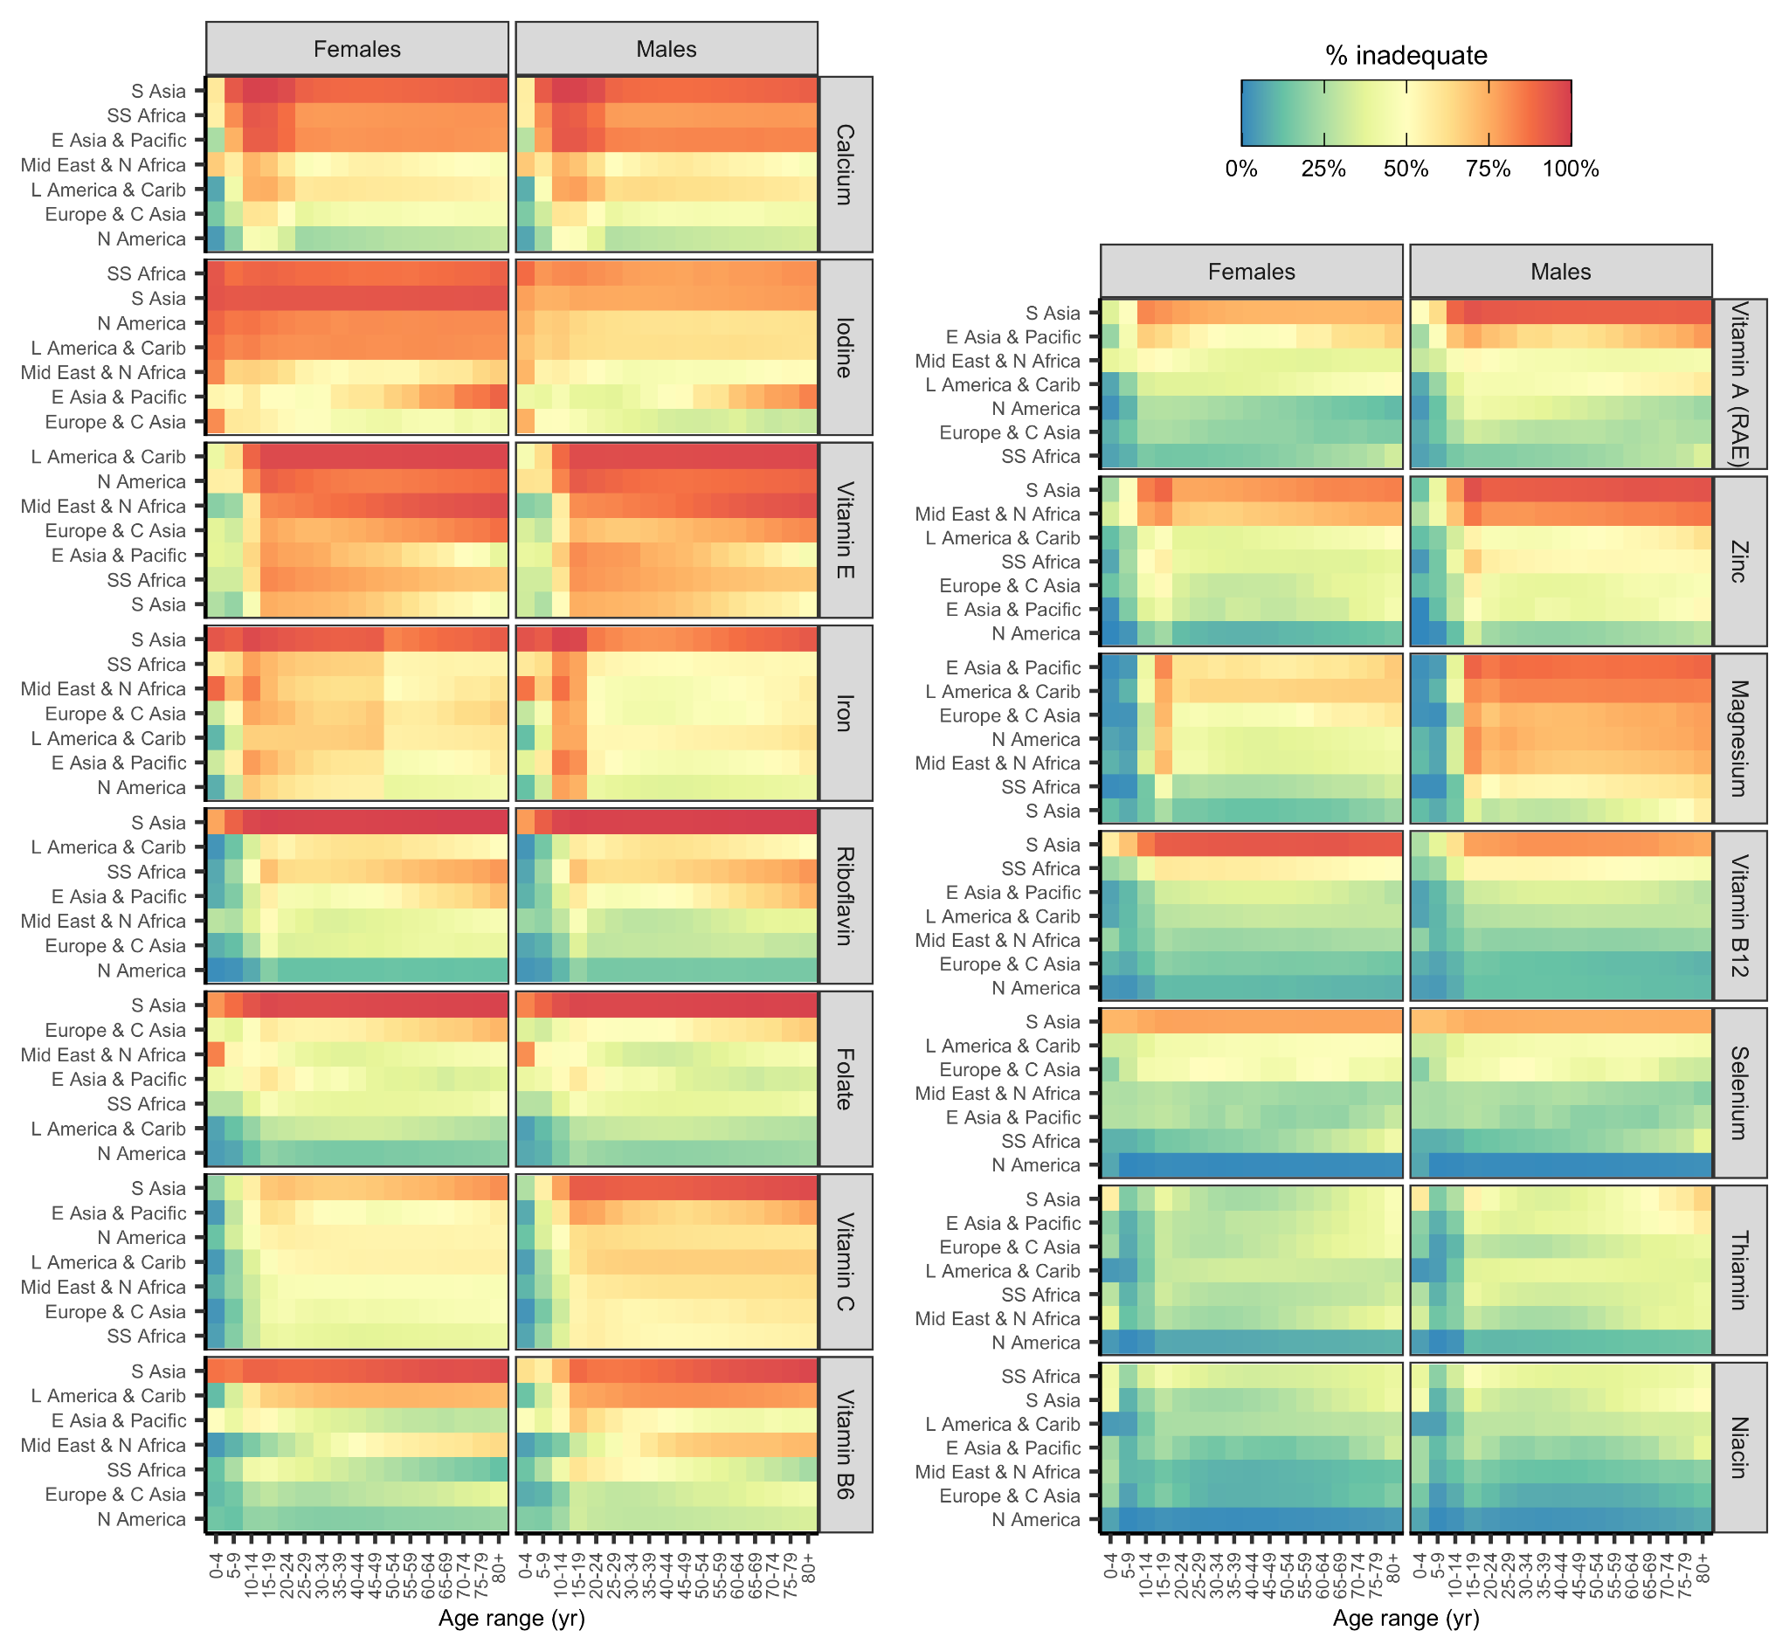**Figure 2.** Prevalence of intake inadequacies by World Bank region and nutrient in 2018. Nutrients and regions are arranged in order of decreasing prevalence of inadequate intakes. Region abbreviations: S=South, N=North, C=Central, SS=Sub-Saharan, Mid=Middle, L=Latin, Carib=Caribbean, NZ=New Zealand. See **Figure S12** for a map of the World Bank regions.

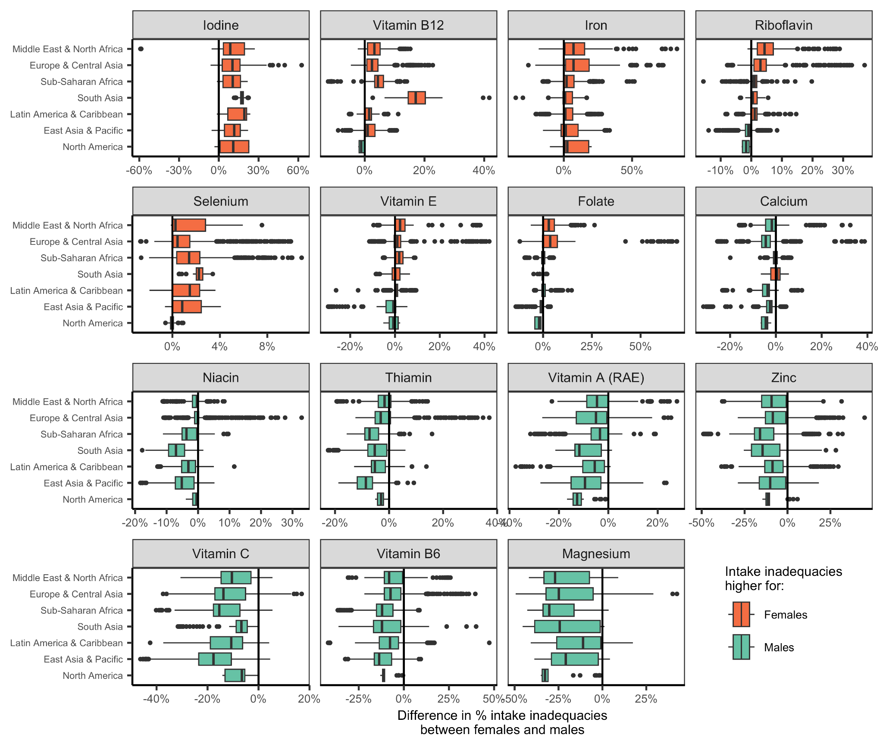**Figure 3.** Distribution of subnational differences in the prevalence of intake inadequacies between females and males by World Bank region. Values greater than zero indicate higher levels of intake inadequacies in females relative to males in the same country and age group. Values less than zero indicate higher levels of intake inadequacies in males relative to females in the same country and age group. In the boxplots, the solid line indicates the median, the box indicates the interquartile range (IQR; 25th to 75th percentiles), the whiskers indicate 1.5 times the IQR, and the points beyond the whiskers indicate outliers. See **Figure S12** for a map of the World Bank regions.

## Supplemental Tables and Figures

**Table S1.** Nutrients included in analysis (AR=average requirement; IOM=U.S. Institute of Medicine; EFSA=European Food Safety Authority).

|  |  |  |  |  |  |
| --- | --- | --- | --- | --- | --- |
|  |  |  |  | **Prevalence of inadequacies** |  |
| **Type** | **Nutrient** | **Units** | **AR source** | **Billions of people** | **% of people** |
| Vitamin | Vitamin E | mg | IOM | 5.07 | 67.0% |
| Vitamin | Riboflavin (vitamin B2) | mg | EFSA | 4.12 | 54.4% |
| Vitamin | Folate (vitamin B9) | µg DFE | EFSA | 4.06 | 53.6% |
| Vitamin | Vitamin C | mg | EFSA | 4.04 | 53.3% |
| Vitamin | Vitamin B6 (pyridoxine) | mg | EFSA | 3.90 | 51.5% |
| Vitamin | Vitamin A (RAE) | µg RAE | EFSA | 3.63 | 47.9% |
| Vitamin | Vitamin B12 (cobalamin) | ug | IOM | 2.97 | 39.3% |
| Vitamin | Thiamin (vitamin B1) | mg | IOM | 2.25 | 29.8% |
| Vitamin | Niacin (vitamin B3) | mg | IOM | 1.68 | 22.2% |
| Mineral | Calcium | mg | EFSA | 5.46 | 72.1% |
| Mineral | Iron | mg | EFSA | 5.12 | 67.6% |
| Mineral | Iodine | ug | IOM | 4.90 | 64.7% |
| Mineral | Zinc | mg | EFSA | 3.48 | 45.9% |
| Mineral | Magnesium | mg | IOM | 3.36 | 44.4% |
| Mineral | Selenium | ug | IOM | 2.83 | 37.4% |

**Table S2.** Dietary factors included in the Global Dietary Database (GDD). *** animal-source food used to derive average requirements for iron (see **Figures S8 and S10**).

|  |  |  |
| --- | --- | --- |
| **Type** | **Factor** | **Units** |
| Vitamins | Folate | µg DFE |
| Vitamins | Vitamin A (RAE) | µg RAE |
| Vitamins | Vitamin B1 | mg |
| Vitamins | Vitamin B12 | µg |
| Vitamins | Vitamin B2 | mg |
| Vitamins | Vitamin B3 | mg |
| Vitamins | Vitamin B6 | mg |
| Vitamins | Vitamin C | mg |
| Vitamins | Vitamin D | µg |
| Vitamins | Vitamin E | mg |
| Minerals | Calcium | mg |
| Minerals | Iodine | µg |
| Minerals | Iron | mg |
| Minerals | Magnesium | mg |
| Minerals | Potassium | mg |
| Minerals | Selenium | µg |
| Minerals | Zinc | mg |
| Fatty acids | Monounsaturated fatty acids | % of total kcal |
| Fatty acids | Plant omega-3 fatty acids | mg |
| Fatty acids | Saturated fat | % of total kcal |
| Fatty acids | Seafood omega-3 fatty acids | mg |
| Fatty acids | Total omega-6 fatty acids | % of total kcal |
| Macronutrients | Added sugars | % of total kcal |
| Macronutrients | Dietary cholesterol | mg |
| Macronutrients | Dietary fiber | g |
| Macronutrients | Dietary sodium | mg |
| Macronutrients | Total carbohydrates | % of total kcal |
| Macronutrients | Total protein | g |
| Beverages | Coffee | cups |
| Beverages | Fruit juices | g |
| Beverages | Sugar-sweetened beverages | g |
| Beverages | Tea | cups |
| Beverages | Total milk | g |
| Foods | Beans and legumes | g |
| Foods | Cheese | g |
| Foods | Eggs *** | g |
| Foods | Fruits | g |
| Foods | Non-starchy vegetables | g |
| Foods | Nuts and seeds | g |
| Foods | Other starchy vegetables | g |
| Foods | Potatoes | g |
| Foods | Refined grains | g |
| Foods | Total processed meats *** | g |
| Foods | Total seafoods *** | g |
| Foods | Unprocessed red meats *** | g |
| Foods | Whole grains | g |
| Foods | Yoghurt (including fermented milk) | g |

**Table S3.** Countries without Global Dietary Database (GDD) data and the nearest geographical neighbor from which they borrow data. See **Figure S2** for a visualization of this matching.

​

|  |  |  |  |
| --- | --- | --- | --- |
| **Country without GDD data** | | **Country with GDD data** | |
| **ISO3** | **Country** | **ISO3** | **Country** |
| ASM | American Samoa | WSM | Samoa |
| AND | Andorra | FRA | France |
| ABW | Aruba | VEN | Venezuela |
| BMU | Bermuda | USA | United States |
| VGB | British Virgin Islands | LCA | St. Lucia |
| CYM | Cayman Islands | JAM | Jamaica |
| CHI | Channel Islands | GBR | England |
| CUW | Curaçao | VEN | Venezuela |
| FRO | Faroe Islands | DNK | Denmark |
| PYF | French Polynesia | WSM | Samoa |
| GIB | Gibraltar | ESP | Spain |
| GRL | Greenland | DNK | Denmark |
| GUM | Guam | FSM | Micronesia (Federated States of) |
| HKG | Hong Kong SAR China | CHN | China |
| IMN | Isle of Man | GBR | England |
| XKX | Kosovo | SRB | Serbia |
| LIE | Liechtenstein | CHE | Switzerland |
| MAC | Macao SAR China | CHN | China |
| MCO | Monaco | FRA | France |
| NRU | Nauru | MHL | Marshall Islands |
| NCL | New Caledonia | VUT | Vanuatu |
| PRK | North Korea | KOR | South Korea |
| MNP | Northern Mariana Islands | FSM | Micronesia (Federated States of) |
| PLW | Palau | FSM | Micronesia (Federated States of) |
| PRI | Puerto Rico | CUB | Cuba |
| MAF | Saint Martin (French part) | LCA | St. Lucia |
| SMR | San Marino | ITA | Italy |
| SXM | Sint Maarten | LCA | St. Lucia |
| SOM | Somalia | ETH | Ethiopia |
| KNA | St. Kitts & Nevis | LCA | St. Lucia |
| TCA | Turks & Caicos Islands | BHS | Bahamas |
| TUV | Tuvalu | WSM | Samoa |
| VIR | U.S. Virgin Islands | USA | United States |

**Table S4.** Mapping Global Dietary Database (GDD) age groups to match the World Bank (WB) age groups.

|  |  |
| --- | --- |
| **GDD age group** | **WB age group** |
| 0-11 mo | 0-4 yr |
| 12-23 mo | 0-4 yr |
| 2-5 yr | 0-4 yr |
| 6-10 yr | 5-9 yr |
| 11-14 yr | 10-14 yr |
| 15-19 yr | 15-19 yr |
| 20-24 yr | 20-24 yr |
| 25-29 yr | 25-29 yr |
| 30-34 yr | 30-34 yr |
| 35-39 yr | 35-39 yr |
| 40-44 yr | 40-44 yr |
| 45-49 yr | 45-49 yr |
| 50-54 yr | 50-54 yr |
| 55-59 yr | 55-59 yr |
| 60-64 yr | 60-64 yr |
| 65-69 yr | 65-69 yr |
| 70-74 yr | 70-74 yr |
| 75-79 yr | 75-79 yr |
| 80-84 yr | 80+ yr |
| 85-89 yr | 80+ yr |
| 90-94 yr | 80+ yr |
| 95+ yr | 80+ yr |

**Table S5.** Key assumptions made throughout analysis.

|  |  |
| --- | --- |
| **#** | **Assumption** |
| 1 | Median subnational nutrient intakes in countries without GDD data are similar to neighboring countries with GDD data. |
| 2 | Intake distribution shapes for subnational groups without nutriR data can be borrowed, in order of preference, from the nearest age-sex group, the opposite sex, or the country with the most similar diet. |
| 3 | When intake distributions shift higher or lower, the median changes but the shape remains the same. |
| 4 | The requirement distribution for Vitamin B12 has a coefficient of variation (CV) of 0.25 and the requirement distributions of all other nutrients have CVs of 0.10. |
| 5 | We do not quantitatively evaluate the impact of fortified foods. |

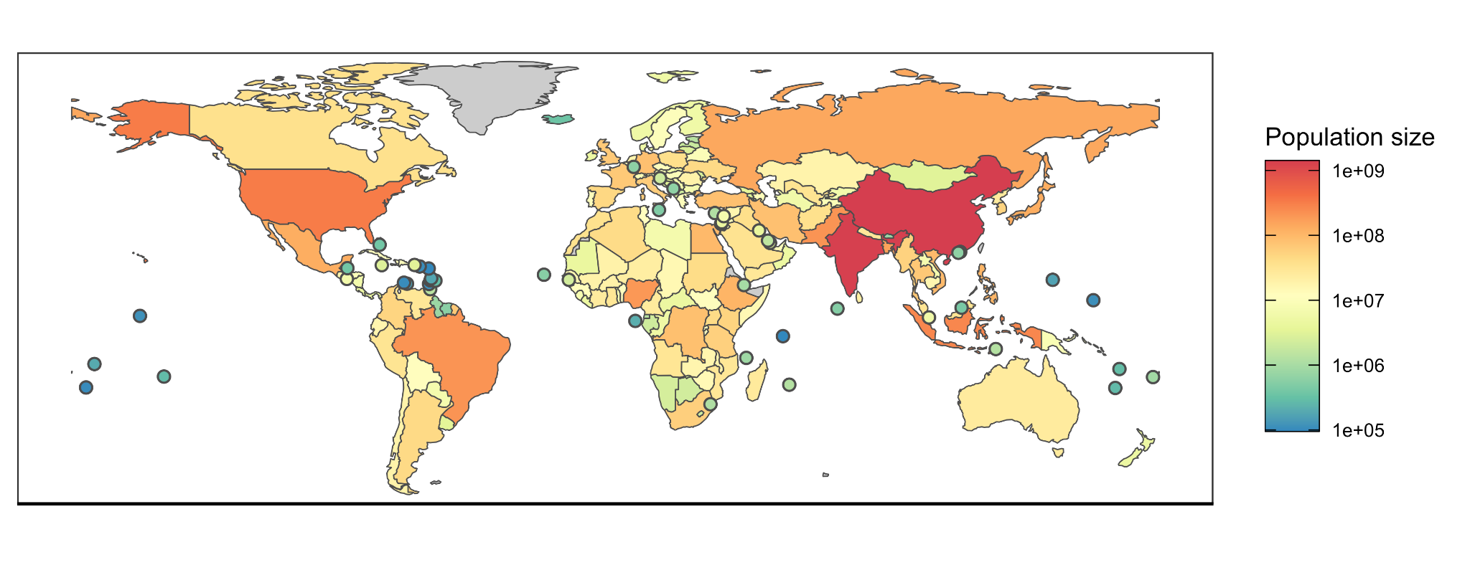**Figure S1.** Human population size in 2018 from the World Bank.[25](https://www.zotero.org/google-docs/?b9Sl9Z) Countries with land areas less than 25,000 km2 are shown as points to increase visibility.

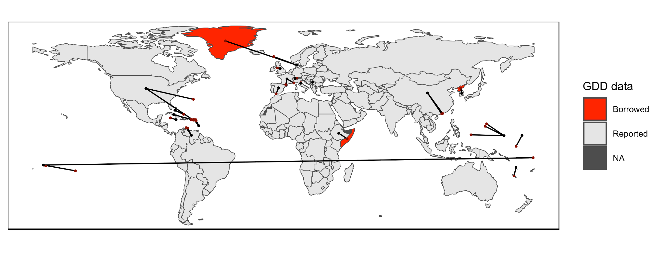**Figure S2.** Coverage of the Global Dietary Database (GDD)[19](https://www.zotero.org/google-docs/?Mq0ARL) and countries used to supply data to countries without data. Light gray countries are countries with GDD data and red countries are countries without GDD data. Lines indicate which countries with data are assumed to be representative of the countries without data.

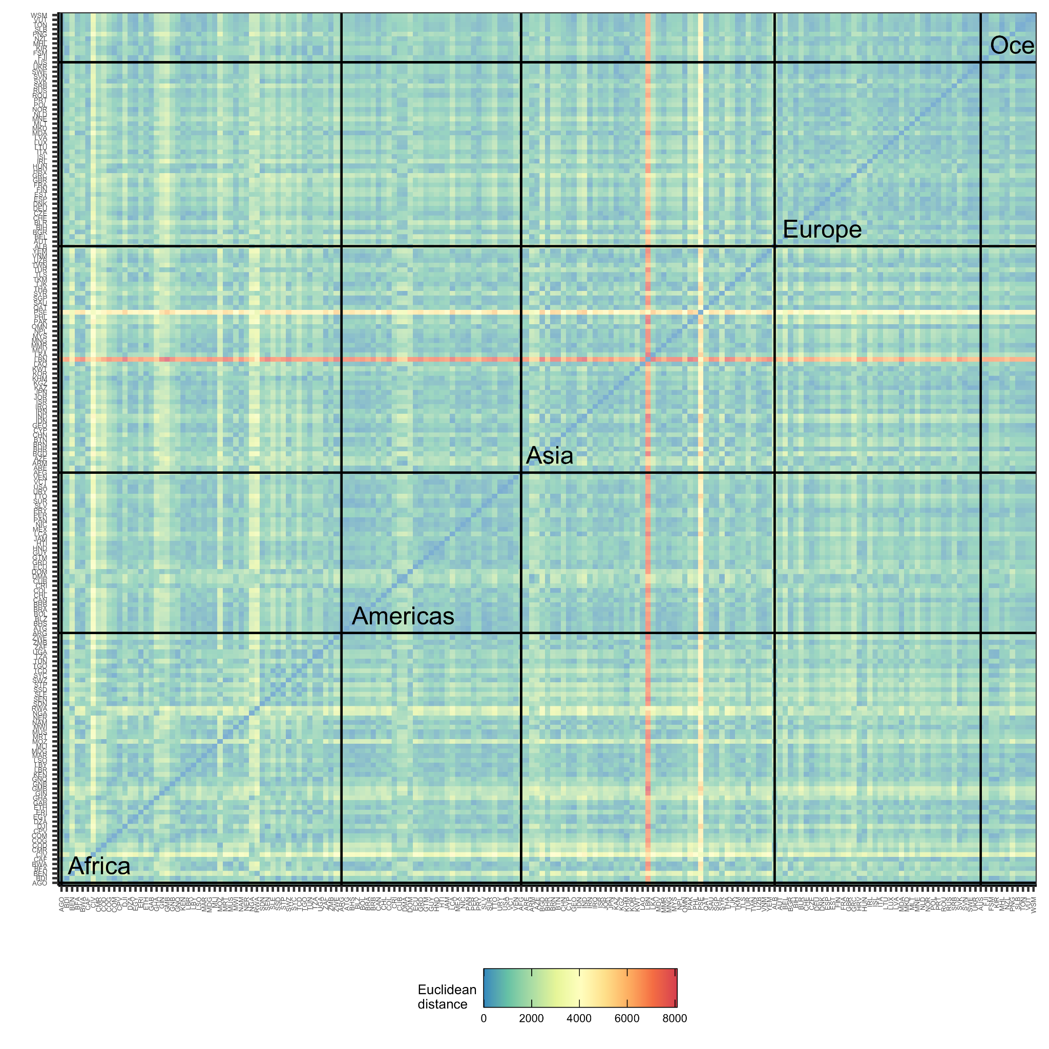**Figure S3.** The Euclidean distance between the nutrient intakes of the 185 countries with GDD intake estimates. Euclidean distances were calculated using national averages of vitamin and mineral intakes. Small Euclidean distances indicate countries with very similar national-scale nutrient intakes and large Euclidean distances indicate countries with very different national scale nutrient intakes. See **Table S2** for a list of the vitamins and minerals included in this calculation. Countries are grouped by continent. Palestinian territories (PSE) and Lebanon (LBN) have dramatically different nutrient intakes than every other country (the horizontal and vertical red bands represent extremely far Euclidean distance).

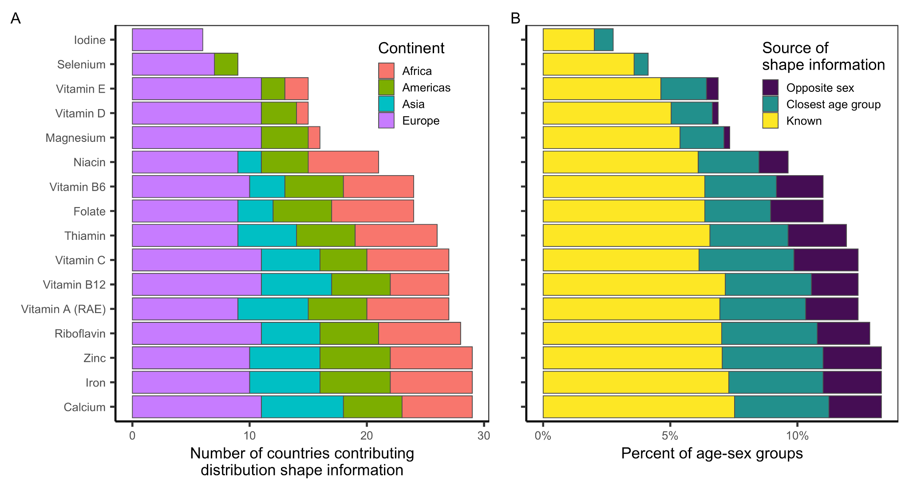**Figure S4.** The availability of distribution shape information for building usual intake distributions for all of the evaluated subnational age-sex groups. Panel A shows the number of countries contributing shape information and Panel B shows the percentage of age-sex groups with known shape information or with shape information borrowed from the closest age group or the opposite group. Shape information for the remaining percentage is borrowed from the corresponding age-sex group from the most similar country (see methods).

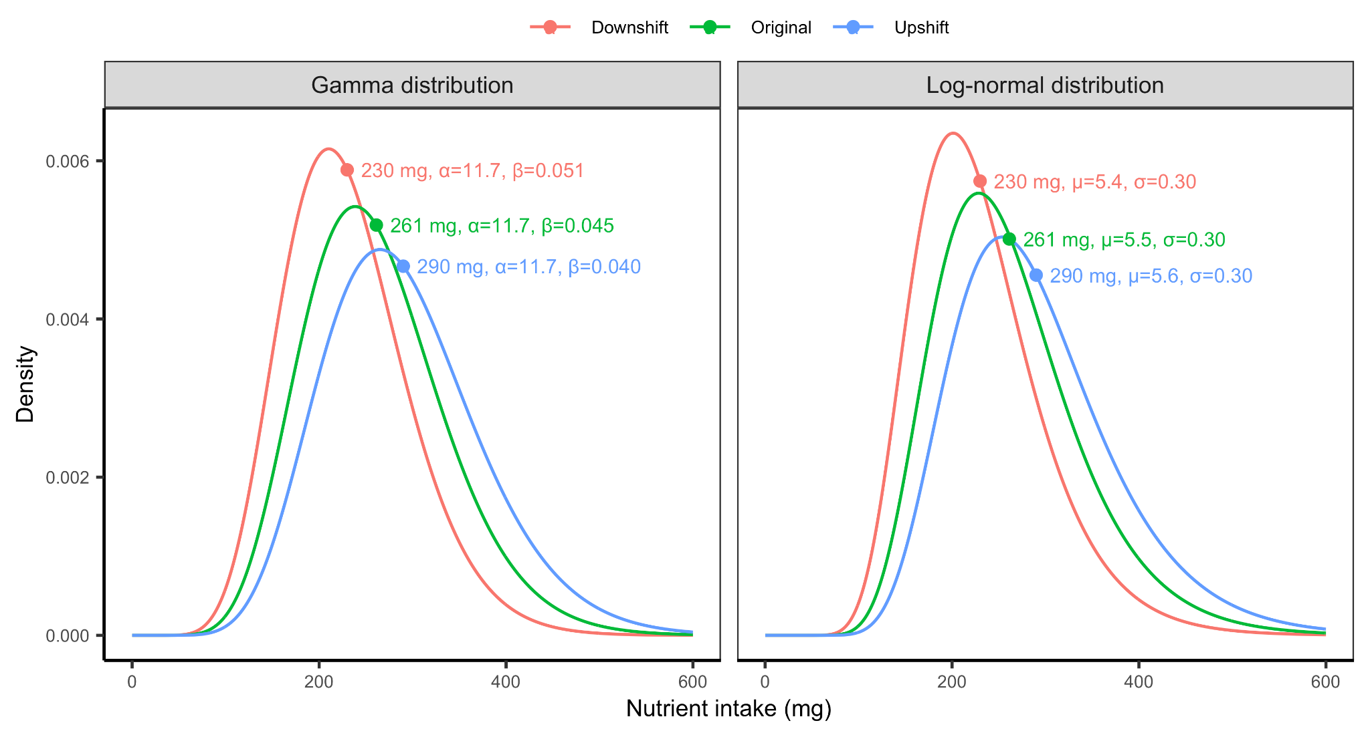**Figure S5.** Conceptual illustration of the methods used to shift the distributions defined by the matched shape parameters to match the Global Dietary Database median for each subnational group. Distributions were shifted by maintaining the variability parameter (*α* and *σ* for the gamma and log-normal distributions, respectively) and shifting the centrality parameter (*β* and *µ* for the gamma and log-normal distributions, respectively).

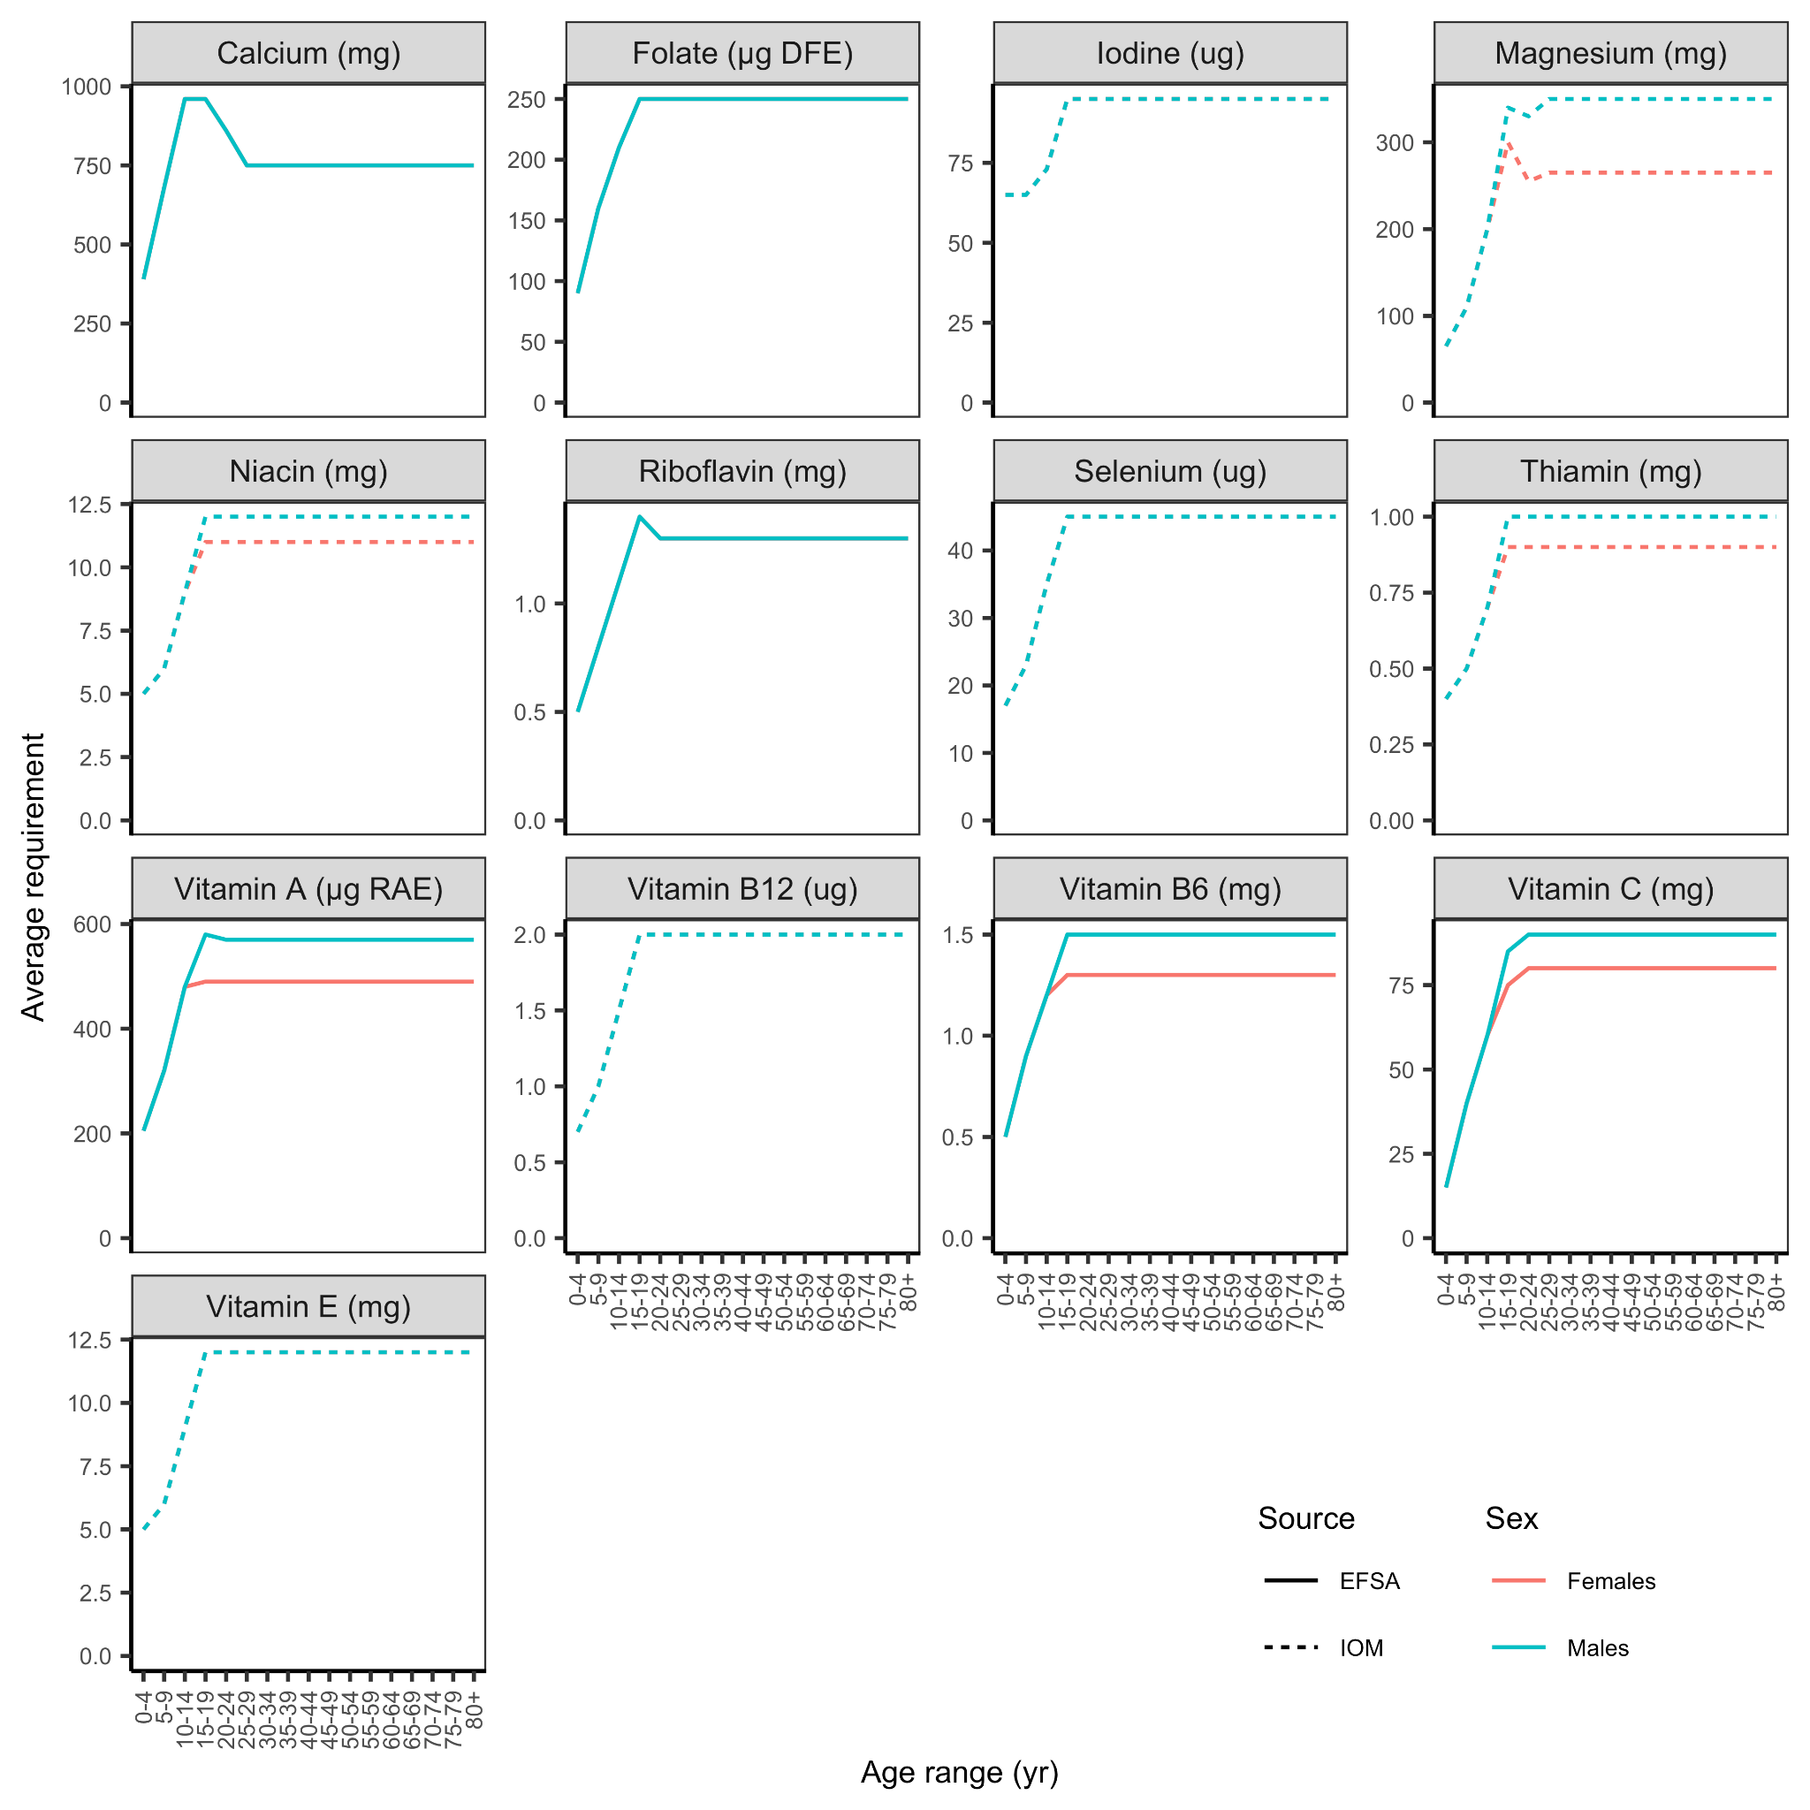**Figure S6.** Harmonized average requirements (H-ARs) from Allen et al.[24](https://www.zotero.org/google-docs/?Vqb6bE) for 13 of 15 nutrients evaluated in this paper. Males and females have identical average requirements for calcium, folate, iodine, riboflavin, selenium, vitamin B12, and vitamin E. Average requirements for iron and zinc are shown in **Figure S7**. Harmonized average requirements are drawn from the U.S. Institute of Medicine (IOM) and European Food Safety Authority (EFSA).

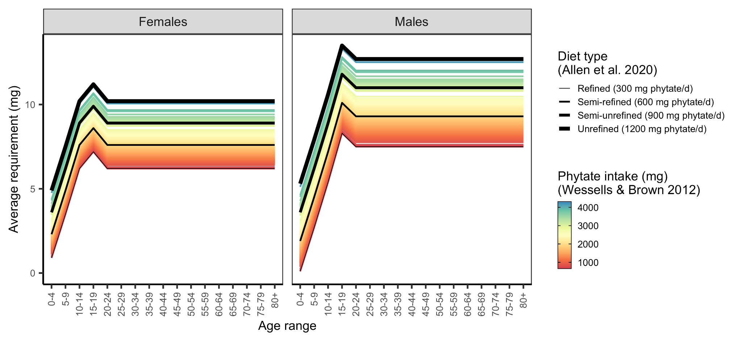**Figure S7.** Average requirements for zinc by age-sex group based on diet type, as specified by Allen et al.[24](https://www.zotero.org/google-docs/?t9v3wA), and 2005 phytate intake, as estimated by Wessells and Brown[32](https://www.zotero.org/google-docs/?TzuX3R). The colored lines represent the requirements estimated for each country.**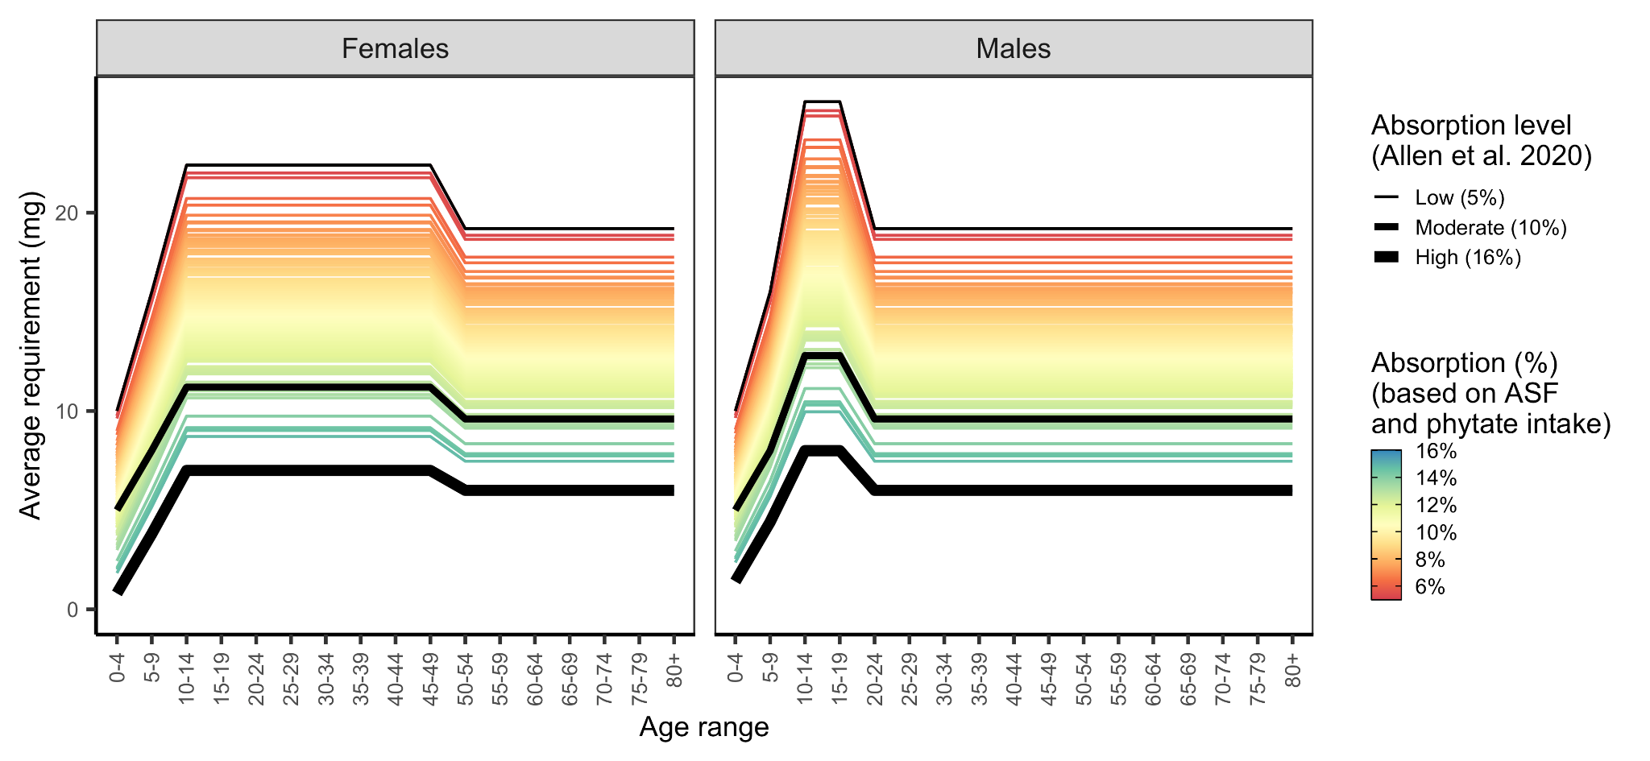Figure S8.** Average requirements for iron by age-sex group based on country-specific absorption levels. Countries were assigned an absorption level based on their phytate (**Figure S9**) and animal-source food (ASF) intakes (i.e., sum of unprocessed red meat, processed meat, seafood, and egg intakes) (**Figure S10**). See **Figure S11** for a map of absorption levels.

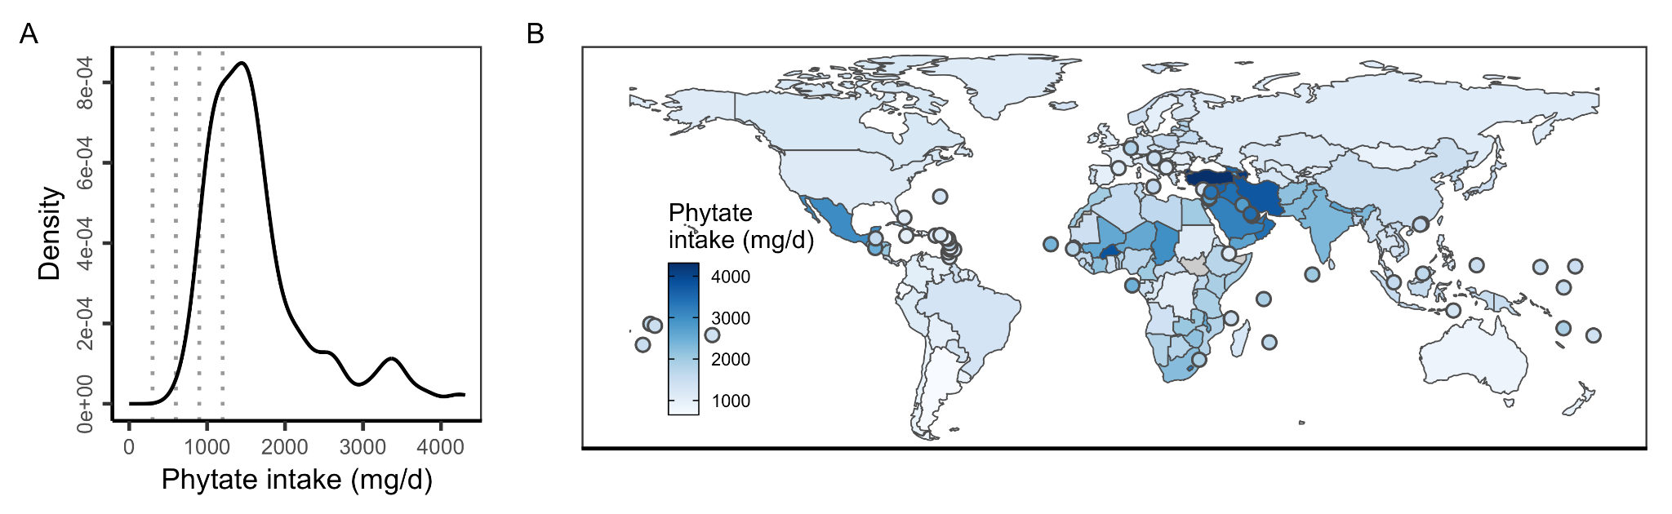**Figure S9.** Phytate intake in 2005 as estimated in Wessells and Brown[32](https://www.zotero.org/google-docs/?ghLy8L). In (A), vertical lines mark the phytate intake reference points used to specify average requirements in Allen et al.[24](https://www.zotero.org/google-docs/?HxTVxg). In **(B)**, countries with land areas less than 25,000 km2 are shown as points to increase visibility.

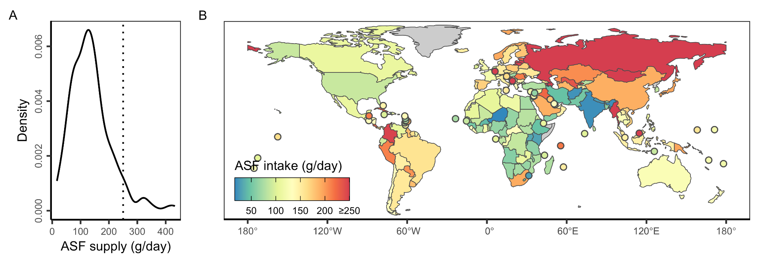**Figure S10.** Average country-level animal-source food (ASF) intake (i.e., sum of unprocessed red meat, processed meat, seafood, and egg intakes) in the Global Dietary Database.[19](https://www.zotero.org/google-docs/?JxevOm) In **(B)** ASF supply is capped at 250 g/day to ease visualization (vertical line in **A**).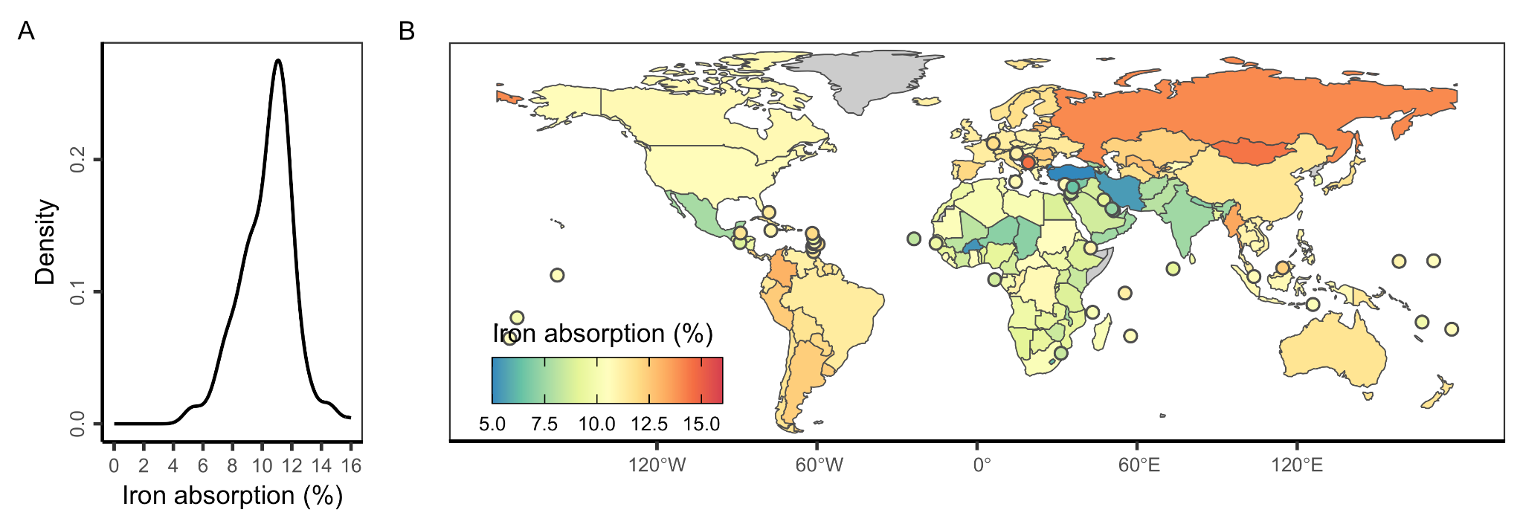

**Figure S11.** Estimated iron absorption levels for each country. Iron absorption levels were estimated based on country-specific phytate (**Figure S9**) and animal-source food (ASF) intakes (i.e., sum of unprocessed red meat, processed meat, seafood, and egg intakes) (**Figure S10**).

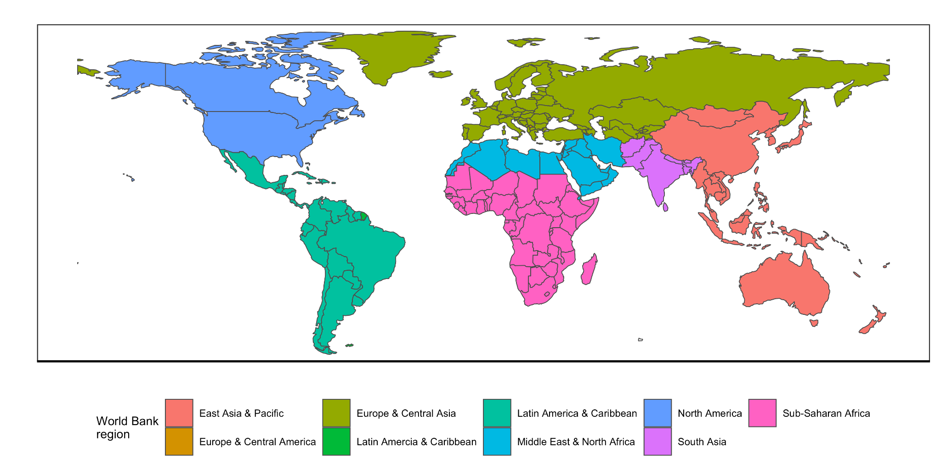

**Figure S12.** World Bank regions used to group results in the main text analysis.